How to run the vector based plugin

Before opening the plugin make sure that all the dataset that are needed to run it are loaded into your QGIS window. The datasets are the following:

Table 1. The datasets needed for the analysis. Their names are not important but the type is crucial.

|  |  |
| --- | --- |
| Dataset | Type |
| Administrative boundaries | Polygon vector |
| Population | Polygon vector |
| GHI | Raster |
| Wind speed | Raster |
| Travel hours | Raster |
| Elevation | Raster |
| Land cover | Raster |
| Custom Demand | Raster |
| Existing HV lines | Lines vector |
| Planned HV lines | Lines vector |
| Existing MV lines | Lines vector |
| Planned MV lines | Lines vector |
| Substations | Points vector |
| Roads | Lines vector |
| Hydropower | Points vector |

**NOTE: When you have made sure that you have all the datasets needed loaded into QGIS please create an empty folder and name it after your country. This folder will serve as your workspace.**

1. **Open** the plugin from the **Database** menu. The name of the plugin when installed will be **GEP OnSSET (Geospatial Electrification Planning OnSSET)**
2. The following window will open up.

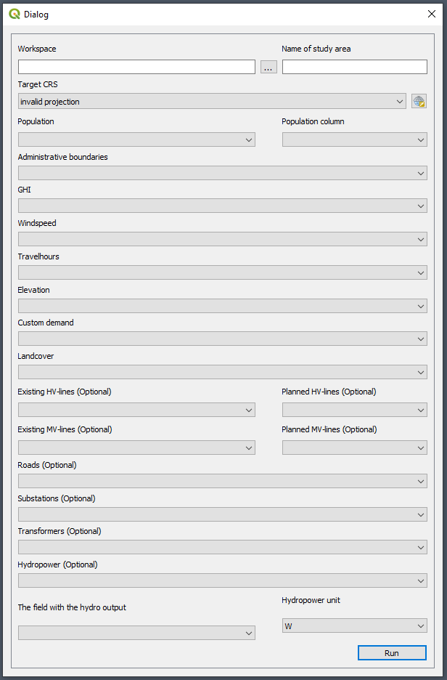

Figure 1. The plugin in use

Below information will follow regarding the use of each box

**Box 1**. This box lets you choose the workspace. Click on the three dots and navigate to the empty folder that you have created previously. When you have found it, select it and continue.

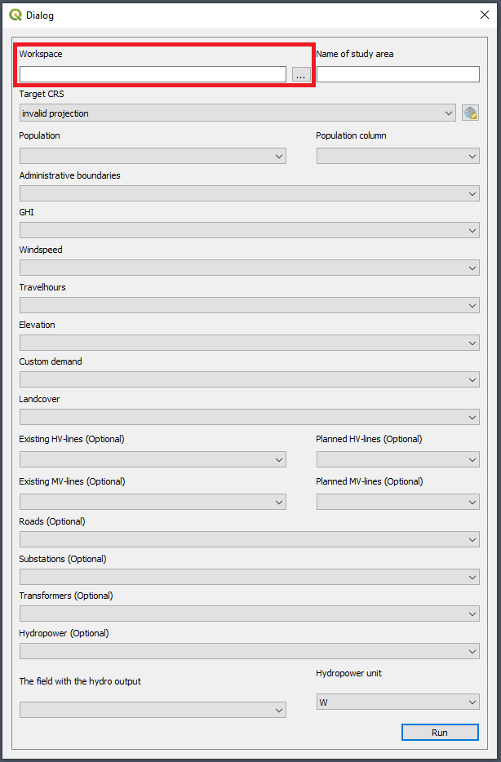

Figure 2. Box 1: enter the workspace by clicking on the button with three dots and navigate to the empty folder you are using as workspace

**Box 2**. Enter the name of your country.

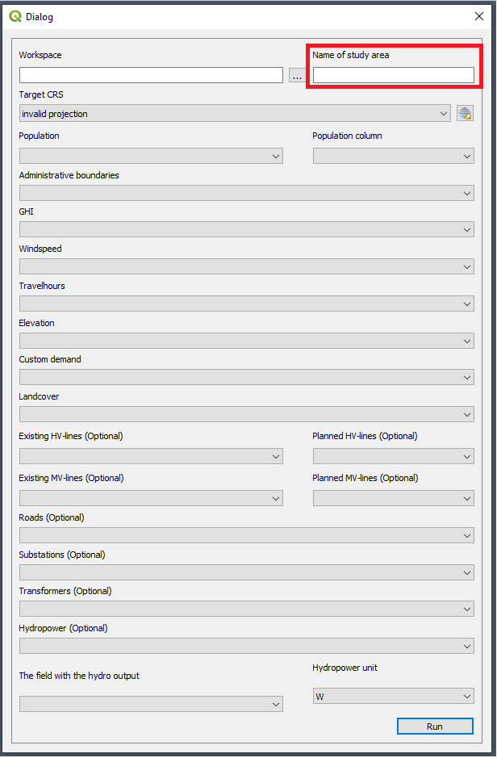

Figure 3. Box:2 Enter the name of the study area

**Box 3**. This box lets you choose an appropriate coordinate system.

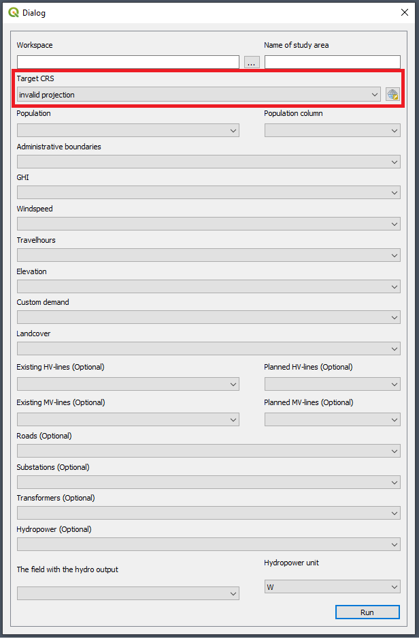

Figure 4. Box 3. Enter the coordinate system that you wish to reproject your data to

To find the coordinate system that is appropriate for your country please visit <http://epsg.io/> and search for your country.

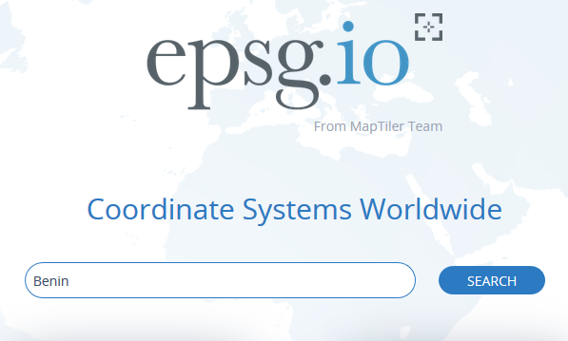

Figure 5. Go to epsg.io and search for the country you want to reproject

This will present you with a list of coordinate systems suitable for your study area.

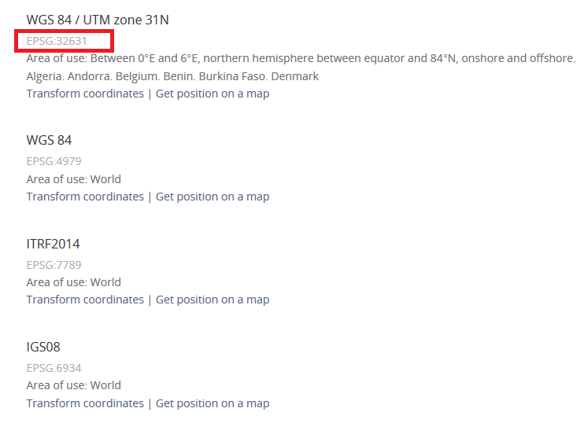

Figure 6. You will get a list of different coordinate systems that fit with your study area. Choose one and note its EPSG code.

Next, come back to QGIS. Click on the icon next to the field and enter the EPSG code received from the webpage. Choose one where the unit is in meters and the red box covers the whole area you are working with.

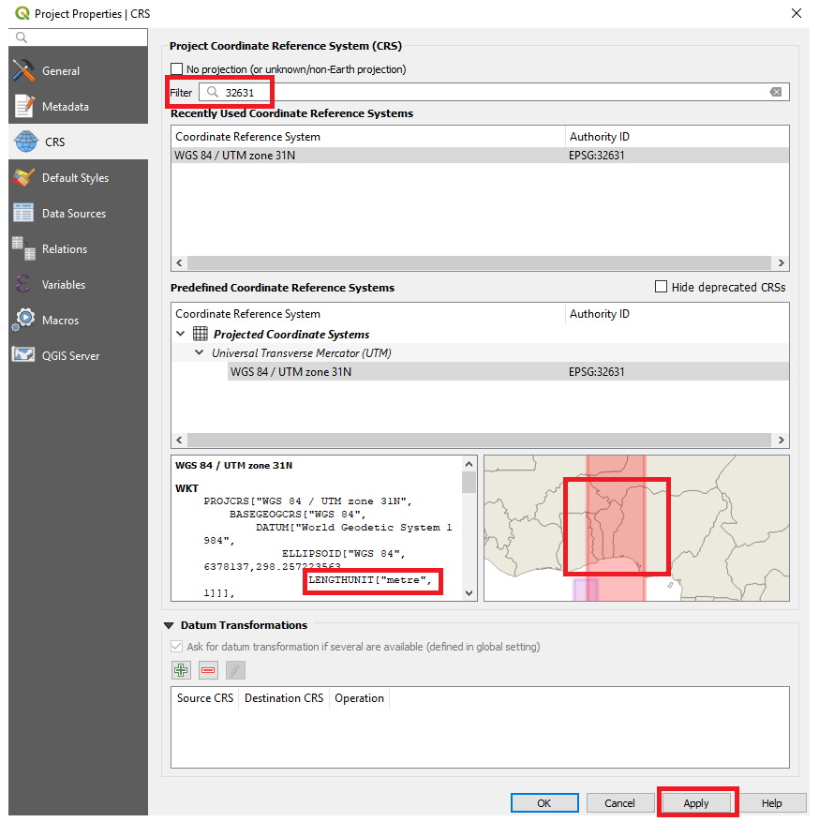

Figure 7. Enter the coordinate system you have chosen in the field. Make sure that the unit is meters (lower left box) and that the red area covers your study area (lower right box)

**Box 4 and 5**. In box 4 select the population dataset. You will have to choose the column that represents the population in the attribute table in box 5.

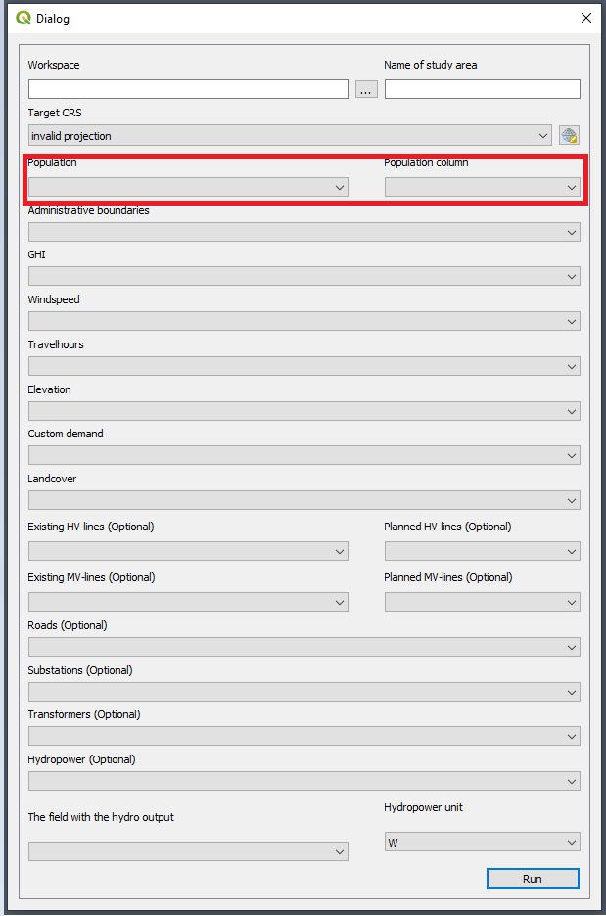

Figure 8. Box 4: enter the population clusters and in Box 5 select the column representing the population

**Box 6 – Box 19.** Select the correct datasets for the boxes. **Note:** that the vector datasets are optional, you are recommended to fill all of them in but in case you are missing some datasets you can leave these boxes empty.

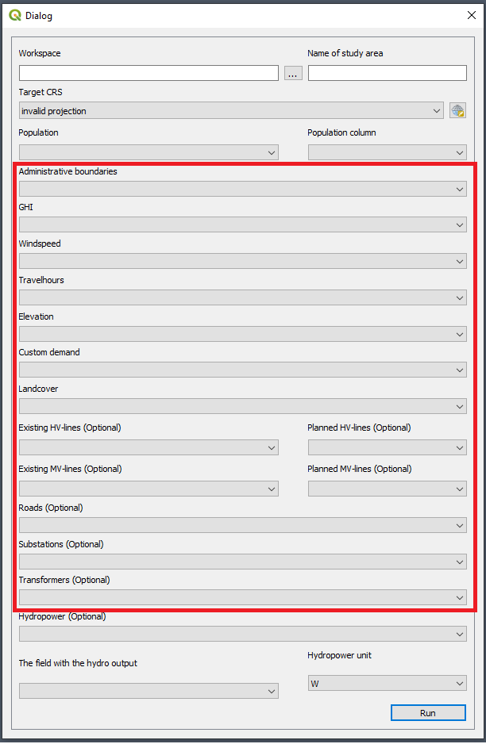

Figure 9. Fill in the correct datasets for each one of these boxes.

**Box 20.**  Click on the box and select the hydropower layer, make sure that it is a point vector.

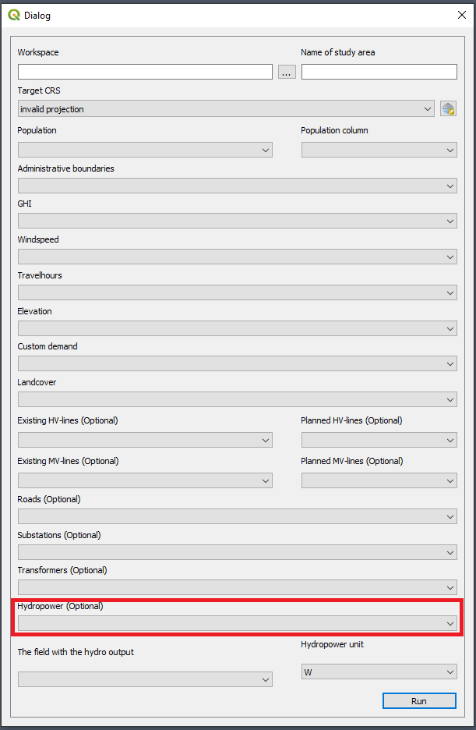

Figure 10. Hydropower points in this to be entered in this box

**Box 21.**  Select the box that includes the hydropower output (In this box you will select a column in the attribute table). The hydropower output is the potential electricity that can be outputted from each plant

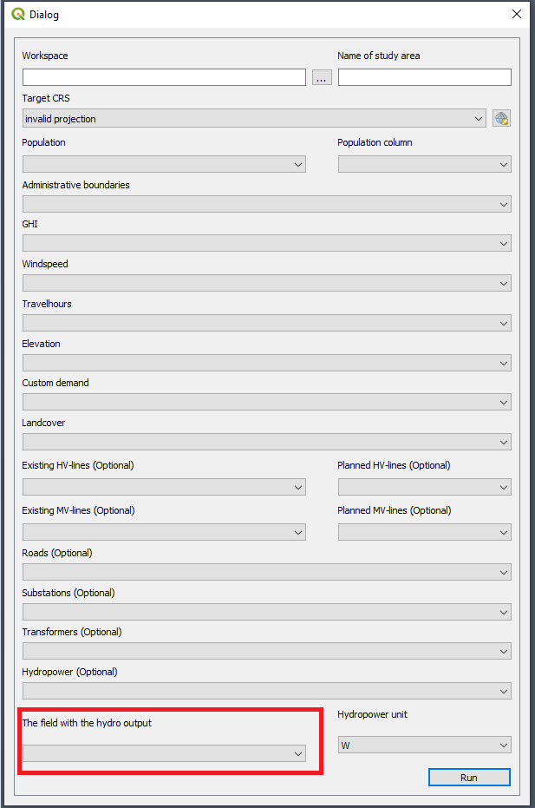

Figure 11. Field in the attribute table that includes the hydropower potential

**Box 22.**  Select the unit of that the hydropower output is given in.

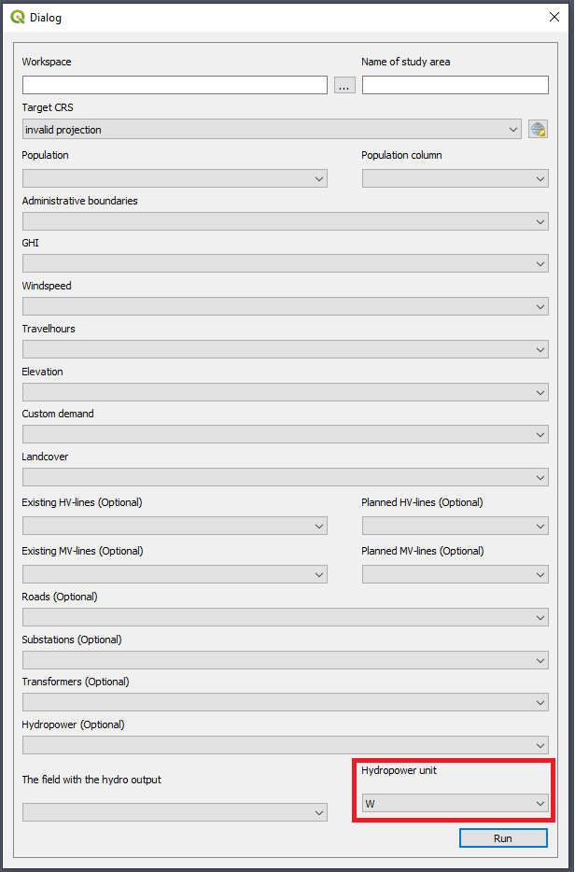

Figure 12. The unit of the values in Box 18

1. When all boxes have the correct data click “Run”. This will run the plugin. This will take between 1-2 hours

**NOTE: While the plugin is running you will not be able to use QGIS. If you try to use QGIS you will get a loading icon. When the loading icon disappears the process is finished.**

1. When the plugin has finished a CSV file with the same name as entered in box 2 will appear in your workspace folder.